Supplemental Material

Detailed Model Parameters

AnyLogic Blocks

Block Picture | Block Name
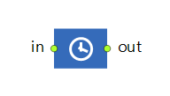 | Delay
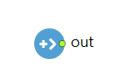 | Source
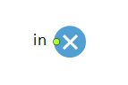 | Sink
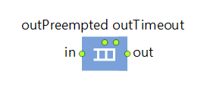 | Queue
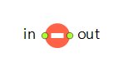 | Hold
 | ResourcePool
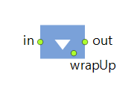 | Seize
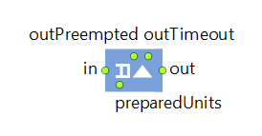 | Release
 | Event
 | Variable
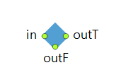 | Select Output

Cost Model and Financial Accounting
The project cost is calculated using an activity-based costing approach. The total cost is a summation of equipment rental (inclusive of fuel, maintenance, and labor), toll fees, and operational duration.
- Unit Costs:
  - Truck: 150 EGP/hour (Inclusive of fuel, maintenance, and driver).
  - Loader: 350 EGP/hour (Inclusive of fuel, maintenance, and driver).
- Toll Fees: A fixed entry cost of 50 EGP is applied per entry.

All amounts originally presented in Egyptian Pounds (EGP) have been converted to United States Dollars (USD) for consistency in the manuscript. For conversion, a representative market exchange rate of 1 USD ≈ 47 EGP has been used, based on prevailing interbank and bank market rates on the date of this submission (Aug 2025)

Emission Modeling and Fuel Consumption
Emissions are derived from the Specific Fuel Consumption (SFC) and Horsepower (HP) of the fleet. The model distinguishes between "Working" (Moving) and "Idle" states.
- Emission Factor: 2.7 kg per liter of diesel fuel.
- Operational Parameters:
  - Truck: 300 HP | Moving LHM: 0.002 | Idle LHM: 0.0008325
  - Loader: 150 HP | Moving LHM: 0.002 | Idle LHM: 0.0008325 (LHM = Liters per Horsepower per Minute)

For modeling simplicity, identical LHM (Liters per Hour per Machine) values were adopted for both trucks (300 HP) and loaders (150 HP) under idle and moving conditions. These parameters are treated as user-defined inputs within the model framework rather than fixed constants. This assumption does not restrict the model’s applicability, as equipment-specific fuel consumption rates can be easily modified. Future work may incorporate differentiated LHM values to capture machine-specific operational characteristics with greater precision.

Stochastic Modeling and GIS Logic

To simulate real-world variability, truck speeds are modeled using Triangular Distributions. Travel times are dynamically calculated using GIS routing between coordinates with an assumption of constant movement (no traffic congestion).
Routing Methodology Note:
Route distances between coordinates were computed using the GIS network embedded within the AnyLogic environment. The road network data is based on OpenStreetMap (OSM), which provides publicly available geographic information. The routing procedure relies on a standard shortest-path algorithm (A*), ensuring that calculated travel distances reflect realistic network-based paths rather than straight-line (Euclidean) distances.

- Truck Speed (Empty): km/h (10, 20, 30)(Min, Mode, Max).
- Truck Speed (Full): km/h (20, 40, 50) (Min, Mode, Max).
Loading Time Formula:
Tload=VtruckQbucket * Tcycle* efficiency factor

Where:
- T(load)→ Loading Time per Truck
- V(truck) → Truck Volume Capacity
- Q(bucket) → Loader Bucket Size
- T(cycle) → Swing / Cycle Time per Bucket

Where 0.083 is the Loading Efficiency Factor.
Bucket swing time (one loading cycle): mins (1.5, 2, 2.5)(Min, Mode, Max).
Dumping time: mins (0.5, 1, 1.2)(Min, Mode, Max).

Simulation Process Flow:
The simulation model follows a discrete-event process flow representing the soil hauling cycle. Initially, the Source block generates agents representing soil batches. The number of generated agents is determined by dividing the total excavation volume by the truck capacity parameter, ensuring that each agent corresponds to a full truckload. Generated agents enter a Queue block, where they wait until the required resources (trucks and loader) become available.

Once resources are available, a Seize block allocates both a truck and a loader. The loading operation is then executed, with loading time calculated based on the number of bucket swings required, defined by the ratio of truck capacity to loader bucket size. After completing the loading process, the loader resource is released while the truck proceeds to the hauling phase.

Truck movement is modeled using GIS-based routing, where travel time is determined from the network distance between the defined origin and destination coordinates. Upon reaching the dumping location, the soil agent is removed from the system, representing material disposal. The truck then returns to the excavation site, after which the truck resource is released to complete the operational cycle.

Scenario-specific constraints are incorporated directly into the process flow. For example, toll delays are modeled using Delay blocks. Similarly, restricted segments such as narrow roads or bridges allowing only one truck at a time are simulated using a Resource Pool containing a single resource unit. Each truck must seize this resource before entering the restricted segment and release it upon exit, ensuring realistic traffic control behavior.

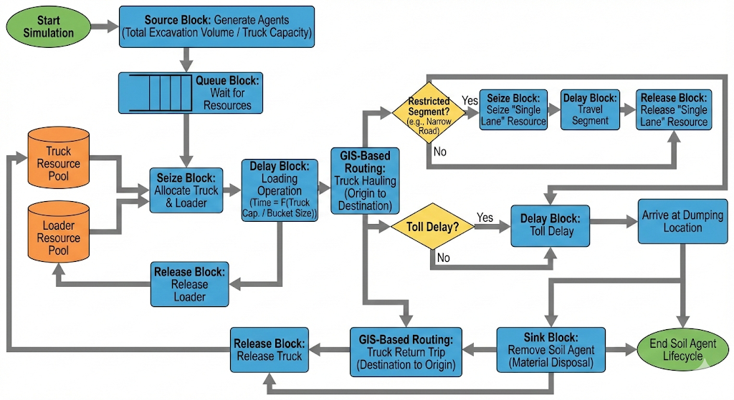

Optimization Settings
The model utilizes the OptQuest optimization engine integrated within AnyLogic, which employs a Genetic Algorithm metaheuristic to explore the decision space.
- Engine: OptQuest (Genetic Algorithm/Scatter Search).
- Iterations: 500 (Maximum limit).
- Stopping Criteria: The experiment terminates either upon reaching the 500-iteration limit or when the objective function value fails to improve significantly over successive generations (automatic convergence).
- Software Version: AnyLogic 8 Personal Learning Edition (Build 8.9.7.202512121159 x64).
- Replicability: The model uses a Random Seed for stochastic variation within iterations.

